**Name:**

**1. AP Calculus AB**

Briar Woods High School

Patrick White, Instructor

2012-2013

**2. Chapter 2 Test A**

This test consists of two sections: a multiple choice section with 18 questions lasting 60 minutes and a short-answer section with 7 question lasting 20 minutes. The use of a graphing calculator is prohibited on all questions of this exam.

Please show all work in the exam booklet and mark your answers on the answer sheet. You will not receive any credit for work shown in the exam booklet.

Please write the honor code on this cover page and sign your name. Failure to do so will result in no credit being awarded for this examination.

On my honor, I have neither given nor received any unauthorized aid on this examination.

**3. AP Calculus AB: Section I**

**4. Minutes - No Calculator**

1. Let $$f(x)=\sqrt{x}$$. What is the equation of the tangent line to $$f$$ at the point $$(4,2)$$?

(A) $$y=\frac{1}{4}x+1$$

(B) $$y=−\frac{1}{2}x+3$$

(C) $$y=\frac{1}{2}x$$

(D) $$y=2x−6$$

(E) None of the above

1. What is the derivative of $$s(t)=sec⁡\sqrt{t}$$?

(A) $$\tan^{2}⁡\sqrt{t}$$

(B) $$sec⁡\frac{1}{2\sqrt{t}}tan⁡\frac{1}{2\sqrt{t}}$$

(C) $$\frac{sec⁡\sqrt{t}tan⁡\sqrt{t}}{2\sqrt{t}}$$

(D) $$sec⁡\sqrt{t}tan⁡\sqrt{t}$$

(E) None of the above

1. If $$f,g$$, and $$h$$ are nonzero differentiable functions, then the derivative of $$\frac{fg}{h}$$ is

(A) $$\frac{fg^{′}+f^{′}g}{h^{′}}$$

(B) $$\frac{fg^{′}h^{′}−fgh^{′}}{h^{2}}$$

(C) $$\frac{fgh^{′}−fg^{′}h−f^{′}gh}{h^{2}}$$

(D) $$\frac{f^{′}gh+fg^{′}h+fgh^{′}}{h^{2}}$$

(E) $$\frac{fg^{′}h+f^{′}gh−fgh^{′}}{h^{2}}$$

1. The line tangent to the curve $$y=\sqrt{16−x}$$ at the point $$(0,4)$$ has slope

(A) 8

(B) 4

(C) $$1/8$$

(D) $$−1/8$$

(E) -8

1. At what point(s) on the curve $$x^{2}−y^{2}+x=2$$ is the tangent line vertical?

(A) $$(1,0)$$ only

(B) $$(−2,0)$$ only

(C) $$(1,\sqrt{2})$$ only

(D) $$(1,0)$$ and $$(−2,0)$$

(E) The tangent line is never vertical

1. If $$y=6cos⁡(3x)$$ then what is $$y^{′}$$?

(A) $$−6sin⁡(3x)$$

(B) $$18sin⁡(x)$$

(C) $$18sin⁡(3x)$$

(D) $$−18sin⁡(3x)$$

(E) None of the above

1. What is the value of

$$\lim_{Δx→0} \frac{2(x+Δx)^{2}−2x^{2}}{Δx}$$

(A) $$2x$$

(B) $$4x$$

(C) 4

(D) 2

(E) Does not exist

1. If $$w(t)=\sqrt{t^{2}−1}$$ what is the value of $$w^{′}(4)$$?

(A) $$\frac{4}{\sqrt{15}}$$

(B) $$\frac{2}{\sqrt{15}}$$

(C) $$\frac{1}{\sqrt{15}}$$

(D) $$\frac{1}{2\sqrt{15}}$$

(E) None of the above

1. At which $$x$$ value does the graph of $$y=3x^{2}−10x+15$$ have a horizontal tangent line?

(A) $$\frac{3}{5}$$

(B) $$\frac{−3}{5}$$

(C) $$\frac{5}{3}$$

(D) $$\frac{−5}{3}$$

(E) None of the above

1. Find $$\frac{dy}{dx}$$ if $$x^{2}+4xy+2y^{2}=16$$

(A) $$\frac{−x−2y}{2x+2y}$$

(B) $$\frac{−2(x+y)}{x+2y}$$

(C) $$\frac{−2(x+y)}{2x+y}$$

(D) $$\frac{−x+2y}{x+y}$$

(E) None of the above

1. At which $$x$$ value(s) does the graph of $$y=2x^{3}−24x+16$$ have a horizontal tangent line?

(A) 1 and -1

(B) 2

(C) 1

(D) 2 and -2

(E) None of the above

1. If $$h(x)=f\left(x^{2}+1\right)$$ then which of the following is true?

(A) $$h^{′}(x)=f^{′}\left(x^{2}+1\right)$$

(B) $$h^{′}(x)=f^{′}(2x)$$

(C) $$h^{′}(x)=2xf^{′}(2x)$$

(D) $$h^{′}(x)=2xf^{′}\left(x^{2}+1\right)$$

(E) None of the above

1. If $$f(x)=10x^{2}−5$$, what is the average rate of change of $$f(x)$$ over the interval

$$−1≤x≤2$$

(A) 10

(B) 30

(C) 20

(D) $$\frac{20}{3}$$

(E) None of the above

1. If $$h(x)=f(x)g(x)$$ and $$f(5)=3,f^{′}(5)=−1,g(5)=−\frac{1}{2},g^{′}(5)=2$$, then what is the value of $$h^{′}(5)$$?

(A) -2

(B) $$\frac{13}{2}$$

(C) $$−\frac{9}{2}$$

(D) $$\frac{9}{2}$$

(E) None of the above

1. If $$f(x)=sin⁡\left(x^{2}+1\right)$$ then find $$f^{′′}(x)$$

(A) $$4x^{2}sin⁡\left(x^{2}+1\right)+2cos⁡\left(x^{2}+1\right)$$

(B) $$−4x^{2}sin⁡\left(x^{2}+1\right)+2cos⁡\left(x^{2}+1\right)$$

(C) $$4x^{2}sin⁡\left(x^{2}+1\right)−2cos⁡\left(x^{2}+1\right)$$

(D) $$−4x^{2}sin⁡\left(x^{2}+1\right)−2cos⁡\left(x^{2}+1\right)$$

(E) None of the above

1. The height (in feet) of a ball thrown vertically upward is given by

$$s(t)=−16t^{2}+32t+64$$

where $$t$$ is in seconds. What is the velocity of the ball at time $$t=3$$ seconds?

(A) $$−64ft/s$$

(B) $$64ft/s$$

(C) $$−16ft/s$$

(D) $$16ft/s$$

(E) None of the above

1. At which point on the graph is the slope of the tangent line closest to the average rate of change of $$f(x)$$ between points $$X$$ and $$Y$$?

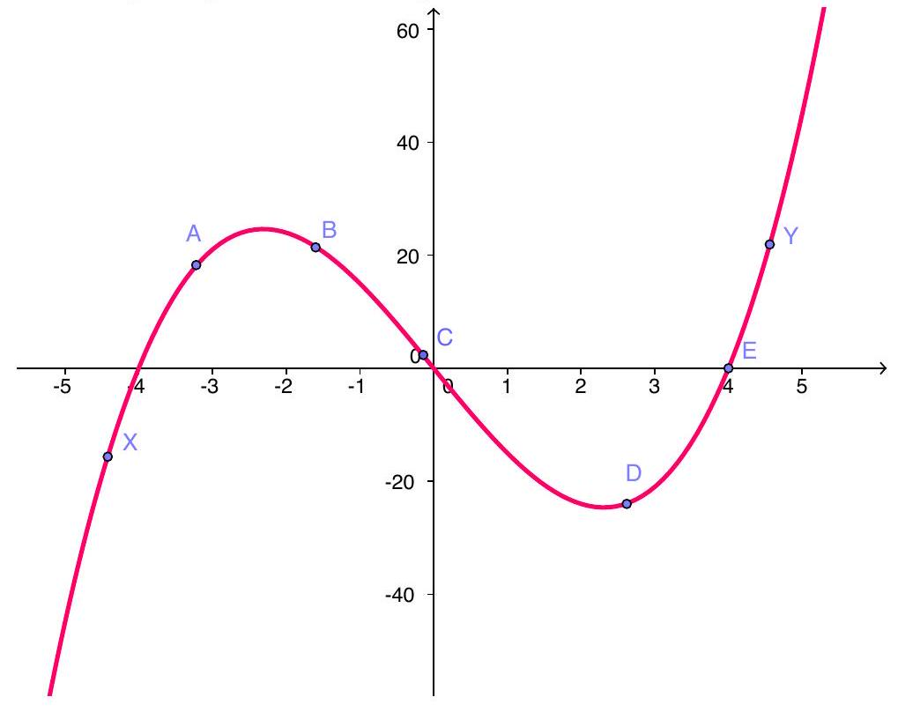

(A) A

(B) $$B$$

(C) $$C$$

(D) $$D$$

(E) $$E$$

1. Let $$f(x)=x^{3}−6x^{2}+10$$. At which point(s) on the graph of $$f$$ is the tangent line parallel to the line $$15x−y=11$$?

(A) $$(2,−6)$$ and $$(−2,22)$$

(B) $$(2,−6)$$ and $$(−2,−22)$$

(C) $$(5,−15)$$ and $$(−1,3)$$

(D) $$(5,−15)$$ and $$(2,−6)$$

(E) None of the above

**5. AP Calculus AB: Section II**

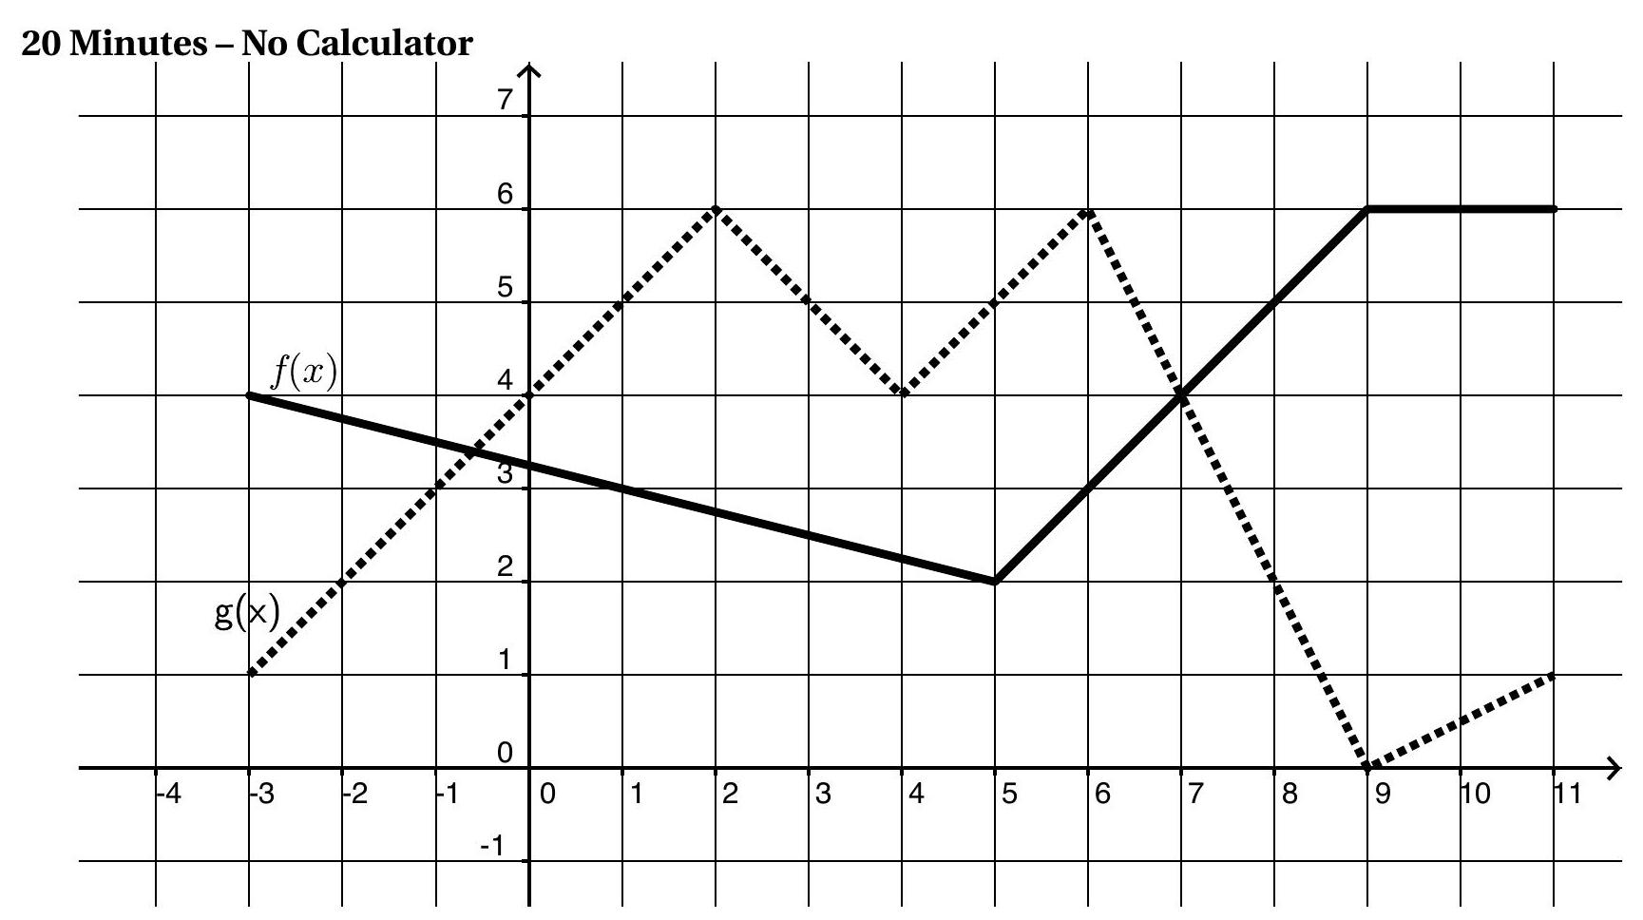

Instructions: In the questions below, find the indicated derivatives using the following definitions

$$\begin{matrix}p(x) & =f(x)g(x) \\ q(x) & =\frac{f(x)}{g(x)} \\ c(x) & =f(g(x)) \\ s(x) & =f(2x)\end{matrix}$$

$$f^{′}(4)=$$

$$g^{′}(−1)=$$

$$p^{′}(1)=$$

$$q^{′}(1)=$$

$$c^{′}(−1)=$$

$$s^{′}(3)=$$

$$p^{′}(7)=$$